<Company> System, Inc.

Intelligent Automation

Support Model

Confidential

Versioning

|  |  |  |  |
| --- | --- | --- | --- |
| Date | Version | Description | Author |
| 15 Nov 2018 | 1.0 | Discussion version – Bob Heelan, David, Srinivas, Robert | Mayank Patel & Shubhen Sarangi, Datamatics |
|  |  |  |  |
|  |  |  |  |

Table of Contents

Introduction 4

Support in the Intelligent Automation Life-cycle 4

Key Stakeholders in Intelligent Automation Support 5

Business Process Owner 5

Process SME 5

Business User 5

L1 Support: <Company> IT Support & Service Team 5

L2 Support: COE Automation Administration Team 5

L3 Support: Intelligent Automation Application Owner 6

<Company> Application Owner Team 6

COE Leadership Team 6

<Company> IT Change Coordinator/Manager 6

Typical Support Initiation, Diagnosis & Handling 7

Support Request from Business Users/Operational Teams 7

Support Request from Bots or Automation COE 7

Support Request (SR) Initiation & Resolution Process: 8

Post Resolution Review & Communication 9

Appendix A: Classification of Support Requests 10

Appendix B: Intelligent Automation Support Knowledge Base 11

# Introduction

RPA and other Intelligent Automation deployments require systematic support processes for quickly and appropriately addressing any issues, incidents or disruptions to business processes. While the Intelligent Automation COE Team monitors the performance, failures and potential issues with deployed automations, a standardized process for support provides means for addressing any incidents that may occur while Bots are in operation.

It is recommended that the Intelligent Automation Support Model is aligned with <Company>’s Support processes and SLAs to avoid any process related confusion.

# Support in the Intelligent Automation Life-cycle

Support for Intelligent Automation deployments is a key element to complete the overall Intelligent Automation Life-cycle. It is inevitable that deployed automations will have issues of varying severity in production. These issues or incidents will require diagnosis, impact analysis and fixing by concerned experts such as Business Process Owner or Process SME, IT Service Desk and/or COE, Application Owner teams. Systematic diagnosis, analysis and fixing of issues will ensure that issues are addressed in a robust manner with required traceability, risk reduction and lessons learnt from incidents. Therefore, particular attention should be paid and sufficient procedure and capacity be planned to requests for change to deployed automations.

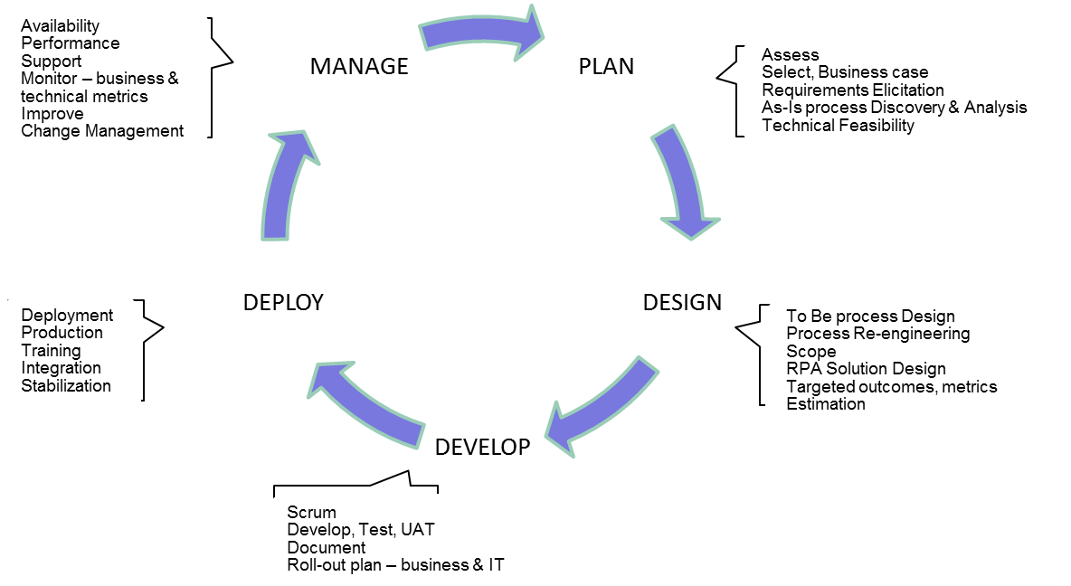

# Key Stakeholders in Intelligent Automation Support

Following are key stakeholders and their principal roles in the Intelligent Automation Support Process:

## Business Process Owner

The concerned Business Process Owner is the primary stakeholder for each support request (SR). Severity, solution approach and delivery timelines are signed-off by the Business Process Owner. He must be part of the decision-making process for prioritization and resolution of issues that impact. Business Process Owner may designate a Process SME to represent the business considerations and any end customer impacts around an issue.

## Process SME

The Business SME provides required process depth to the support, COE IT and other IT & Change Management teams to understand the issue in the context of the automated business process. Business SME is nominated by the Business Process Owner and is required as the latter may not have all finer process details available. Business SME is responsible for validating the facts, process logic and business impacts and for assisting the support, development and change management teams to finalize the planned changes. In high severity situations, it is vital that the Business SME makes themselves available to meet urgent requirements.

## Business User

The first human operator to detect an issue could be either the Business User or the Automation Administrator. A Business User can provides adequate understanding to understand the impact of the issue on a specific task, transaction or operation. Not all Business Users would have the larger understanding of overall business process impact and for this latter understanding for severity, the Business Process SME or Business Process Owner should be consulted.

As a matter of good practice, it is recommended that Business User consult at earliest with Process SME to determine severity/business impact of issue before contacting L1 Support. This will ensure appropriate prioritization of issue from the very beginning and thereby ensure timeliness in response and resolution.

## L1 Support: <Company> IT Support & Service Team

<Company>’s L1 Support Team shall be primary point of contact for all business users who have issues, incidents or questions about any Bots or Intelligent Automation deployments. L1 Support Teams are not subject matter experts in the Intelligent Automation domain and will handle queries to do a first level diagnosis of the issue or problem encountered by a business user. They shall refer to standardized Knowledge Base for conducting this diagnosis and prioritization. L1 Support team shall refer issues to L2 Support (COE Automation Administrators) if they are unable to address and close issue to Business User’s satisfaction. L1 Support Team shall be provided with adequate ‘Read-Only’ access to Management Console (Intelligent Automation Production Dashboard) to review status of any issues.

## L2 Support: COE Automation Administration Team

Automation Administrator(s) in the Intelligent Automation COE shall monitor the health and performance of all Bots/automated business processes and of the production environment. Automation Admin is responsible for pro-actively addressing issues that are communicated and persisted within the Management Console. This will ensure that issues are not waiting upon Business Users or other personas to be addressed. As all issues may not be detected or communicated to end uers, it is vital that the Automation Administrator role has 24x7 coverage if Bots are expected to be operating on a 24x7 routine. The Automation Administrator will analyse and address issues escalated to them by the L1 Support team. In case Automation Admin is unable to resolve and close the issue, he will refer the issue to the L3 Support team for Intelligent Automation.

## L3 Support: Intelligent Automation Application Owner

The Intelligent Automation Application Owner is the overall technical expert for all Intelligent Automation bots deployed in production. This persona (or team of individuals) provide the technical expertise to analyse Bots for possible errors in execution or performance. The Application Owner shall ensure that issues brought to their attention by the COE Automation Admin team is analysed and resolved as per business requirements, technical feasibility so as to meet the severity and turn-around criteria of <Company>’ IT Support standards/SLAs. If any issue requires changes to Bot scripts, then Application Owner will discuss with COE Director and IT Change Coordinator to ensure that such change is handled as per <Company>’s Change Management Process and Procedure.

Based on additional intelligent automation technologies such as AI, ML, ChatBots, OCR, etc., that may be deployed in future, the number of application owners may increase. In such case L3 Support would rely on COE Automation Admin to appropriately direct issues to right application owner.

## <Company> Application Owner Team

In case of issues that may require solutions from other Application Owners within <Company>, then L2 or L3 teams shall reach out to such Application Owner. COE Director and L1 Support Team Manager shall be kept informed of such additional L2, L3 support requirement and such assignment and assistance shall be tracked in ticketing system for monitoring and lessons learnt perspectives.

## COE Leadership Team

Automation COE Director shall be kept informed of all issues with regard to any Bots or automated processes in production or any issues that may occur in the Intelligent Automation Infrastructure. Where required, COE Director and COE Team shall be consulted to ensure that solutions that are optimal and stable from both business and technical perspectives are deployed. COE Director and Application Owner shall review the issues outstanding regularly with Head of IT Support at <Company> to ensure timely resolution of all issues.

## <Company> IT Change Coordinator/Manager

<Company>’s IT Change Coordinator will be informed by Application Owner for Intelligent Automation whenever a code-level or other technical/functionality change to existing Bot is required. As per standard IT Change Process & Procedure the IT Change Coordinator shall Create change record, document all details of required change, plan resources required and communicate any Technical Review other discussions with required stakeholders to initiate the change control process and speedy resolution of the issue. IT Change Coordinator shall obtain all appropriate approvals in Remedy prior to the Change Control Meeting as per <Company> IT Change process. Once Change has been implemented, the IT Change Coordinator closes the loop with the Intelligent Automation Application Owner and other stakeholders, who in turn convey the resolution to business stakeholders.

# Typical Support Initiation, Diagnosis & Handling

Support Requests (SR) may be initiated either by Business Users (Operational Teams) or by COE Administration teams. In each of these cases typical diagnosis will follow the standard checks are per below:

## Support Request from Business Users/Operational Teams

Example:  *the report or process is “doing things wrong” or “throwing bad data”*

L1 Support will follow the following steps based on Knowledge Base specific to the Automated Process:

* Step 1 - service desk is informed of Bot, issue and priority by Business User; reviews if same issue is logged in Management Console; if not logs ticket
* Step 2 - service desk confirms whether issue is listed under ‘Known Issues’ in KB
* Step 2 - service desk confirms “not A” (as per KB article on specific Bot, automated process)
* Step 2 - service desk confirms “not B” (as per KB article on specific Bot, automated process)
* Step 3 - service desk attempts to solve “C” (etc. as per KB article)
* Step q - . . .
* Step r - . . .
* Step n– service desk transfers ticket to Automation COE queue (L2 Support)

## Support Request from Bots or Automation COE

Example:  *the process throws an error to management console (we need to do this because 24 hour timeframe for level 1 to handle). Bots can be configured to raise errors or warnings based on standard Intelligent Automation Platform (Kapow, other platforms) error handling capabilities.*

L2 Support will follow the following steps based on Knowledge Base and additional process specific information available to L2 Support specific to the Automated Process:

* Step 1 – Automation COE confirms not operational issue/business issue (e.g. no volume came in)
* Step 2 – Automation COE checks “not “A”  (If Kapow Down, raise ticket so Service Desk knows)
* Step 3 –  Automation COE checks “not D” – (If system down, raise sev 1 ticket to Service Desk)
* Step q - . . .
* Step r - . . .
* Step n– Automation COE transfers ticket to Application Owner queue (L3 Support)

# Support Request (SR) Initiation & Resolution Process:

All Support Requests shall follow following process to ensure systematic resolution as has been describe in this document. As a matter of good practice reference materials such as Knowledge Base (KB) shall be kept up to date for support teams to provide quick and relevant assistance to address business user and bot issues.

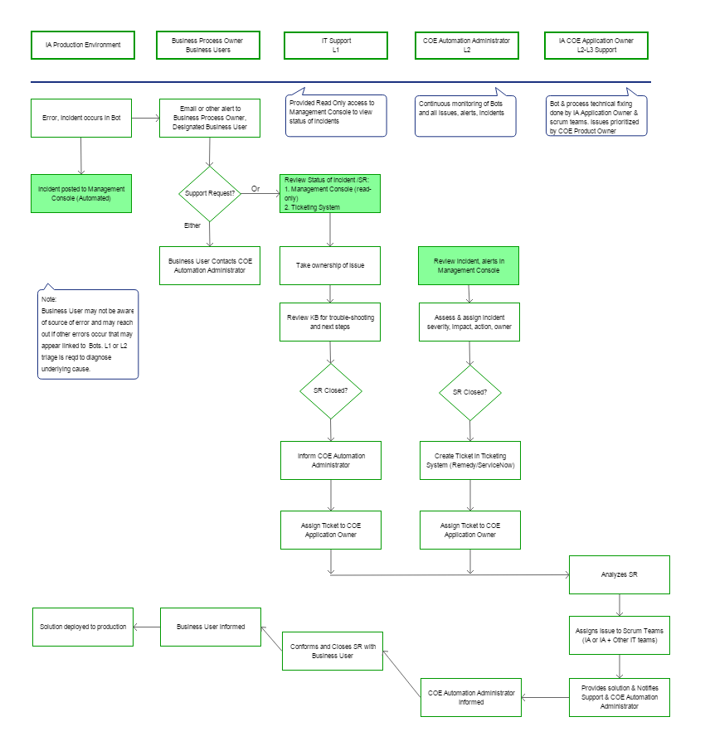

# Post Resolution Review & Communication

The Intelligent Automation COE is responsible for communicating the status of each change request to all stakeholders. This enables Business Process Owners, Support Team, COE IT teams and <Company> IT teams to plan accordingly and eases the integration of the change. All Knowledge Base information should be updated as part of the resolution by the COE.

Whenever IT Change Process is involved in the resolution, the IT Change Manager, Director COE or and Intelligent Automation Application Owner conduct a review of the Change Management process and the results of the Change-implementation. This is logged in the Change Register or Incident Management Tool, and provides a reference for best-practices and lessons that may be learnt for improving handling of future changes.

# Appendix A: Classification of Support Requests

To keep the support process simple and aligned to <Company>’s support practices a simple classification of support requests (SR) should be followed from SR initiation:

|  |  |  |
| --- | --- | --- |
| Risk Assessment | Severity Level | Impacts |
| Minor | 4 | * Nil to Minor impact on business outcomes (e.g., < $10,000) * Workaround exists or volume can be handled by manual processing; * Can wait for 6 months for issue to be addressed |
| Medium | 3 | * Visible impact on business outcomes (e.g, > $10,000 & < $50,000) * Workaround exists or volume can be handled by manual processing * Can wait for 3 months for issue to be addressed |
| Major | 2 | * Considerable impact on business outcomes (e.g, > $50,000 & < $1,000,000 or other major unacceptable business impacts) * Workaround not acceptable or volume cannot be handled completely by manual processing * Can wait for 7 days for issue to be addressed |
| Critical | 1 | * Major impact on operations – impacts multiple customers or key customer account (e.g., > $1,000,000, other unacceptable business impact such as compliance etc.) * Workaround does not exist; No other way to take forward operations * Cannot wait for more than a day to address issue |

Please refer to detailed <Company> severity classification guidelines for additional information on severity levels.

# Appendix B: Intelligent Automation Support Knowledge Base

Following information elements should be recorded for use by L1 Support teams.

Automated Process Information:

* Automate Business Process ID and Name:
* Version of Process:
* Automated Process Business Objective:
* Description:
* Number and Ids of Bots used:

*To clarify cases where multiple Bots are used in single Automated Process*

* Business process Owner:
* Department/Function:
* Process SME:
* Automation Administrator: L2 Support
* Application Owner: L3 Support

Issue Diagnosis and Resolution:

* Known Issues:
* Locate Error Log:
* Defined Error States with Severity & Actions:

*Listing of Errors, Error Identifier codes, with Severity and Actions*

*Severity to be aligned to pre-defined error states/codes*

KB Preparation Guidelines:

* To be prepared by COE prior to release of Bot from Dev to Test environment.
* Update with history, update after each change request
* Link to incidents, incident IDs if possible